NAMA : Fajar Firdaus
NPM : 242310006
KELAS : TI-24-PA1
MATKUL : Lab. Pemrograman Web
LINK GITHUB : https://github.com/jars-ops/PW-MERN-STACK-242310006

cms/_books/components/form.jsx
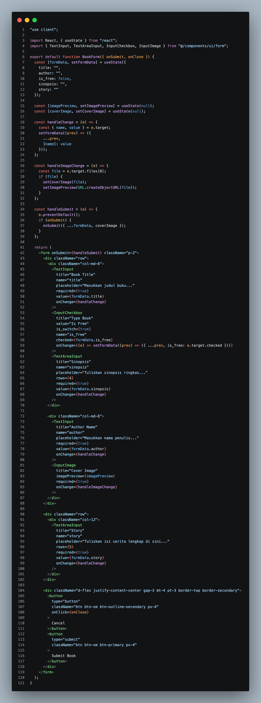
cms/_books/components/header.jsx
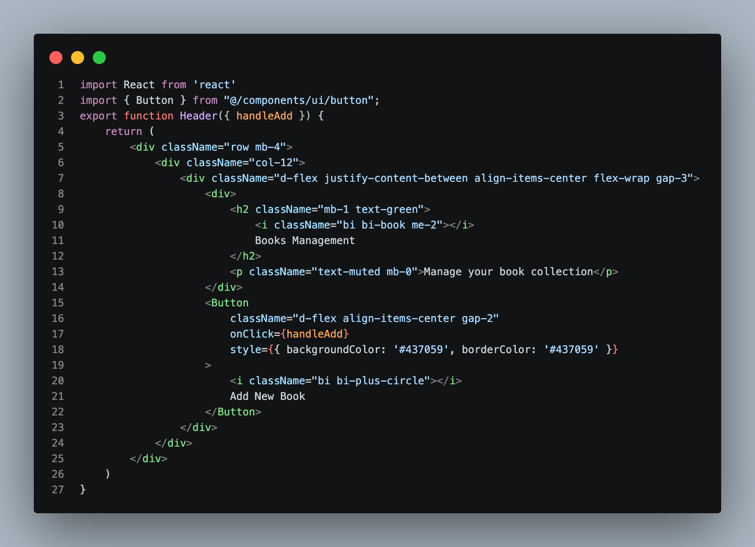

cms/_books/index.jsx
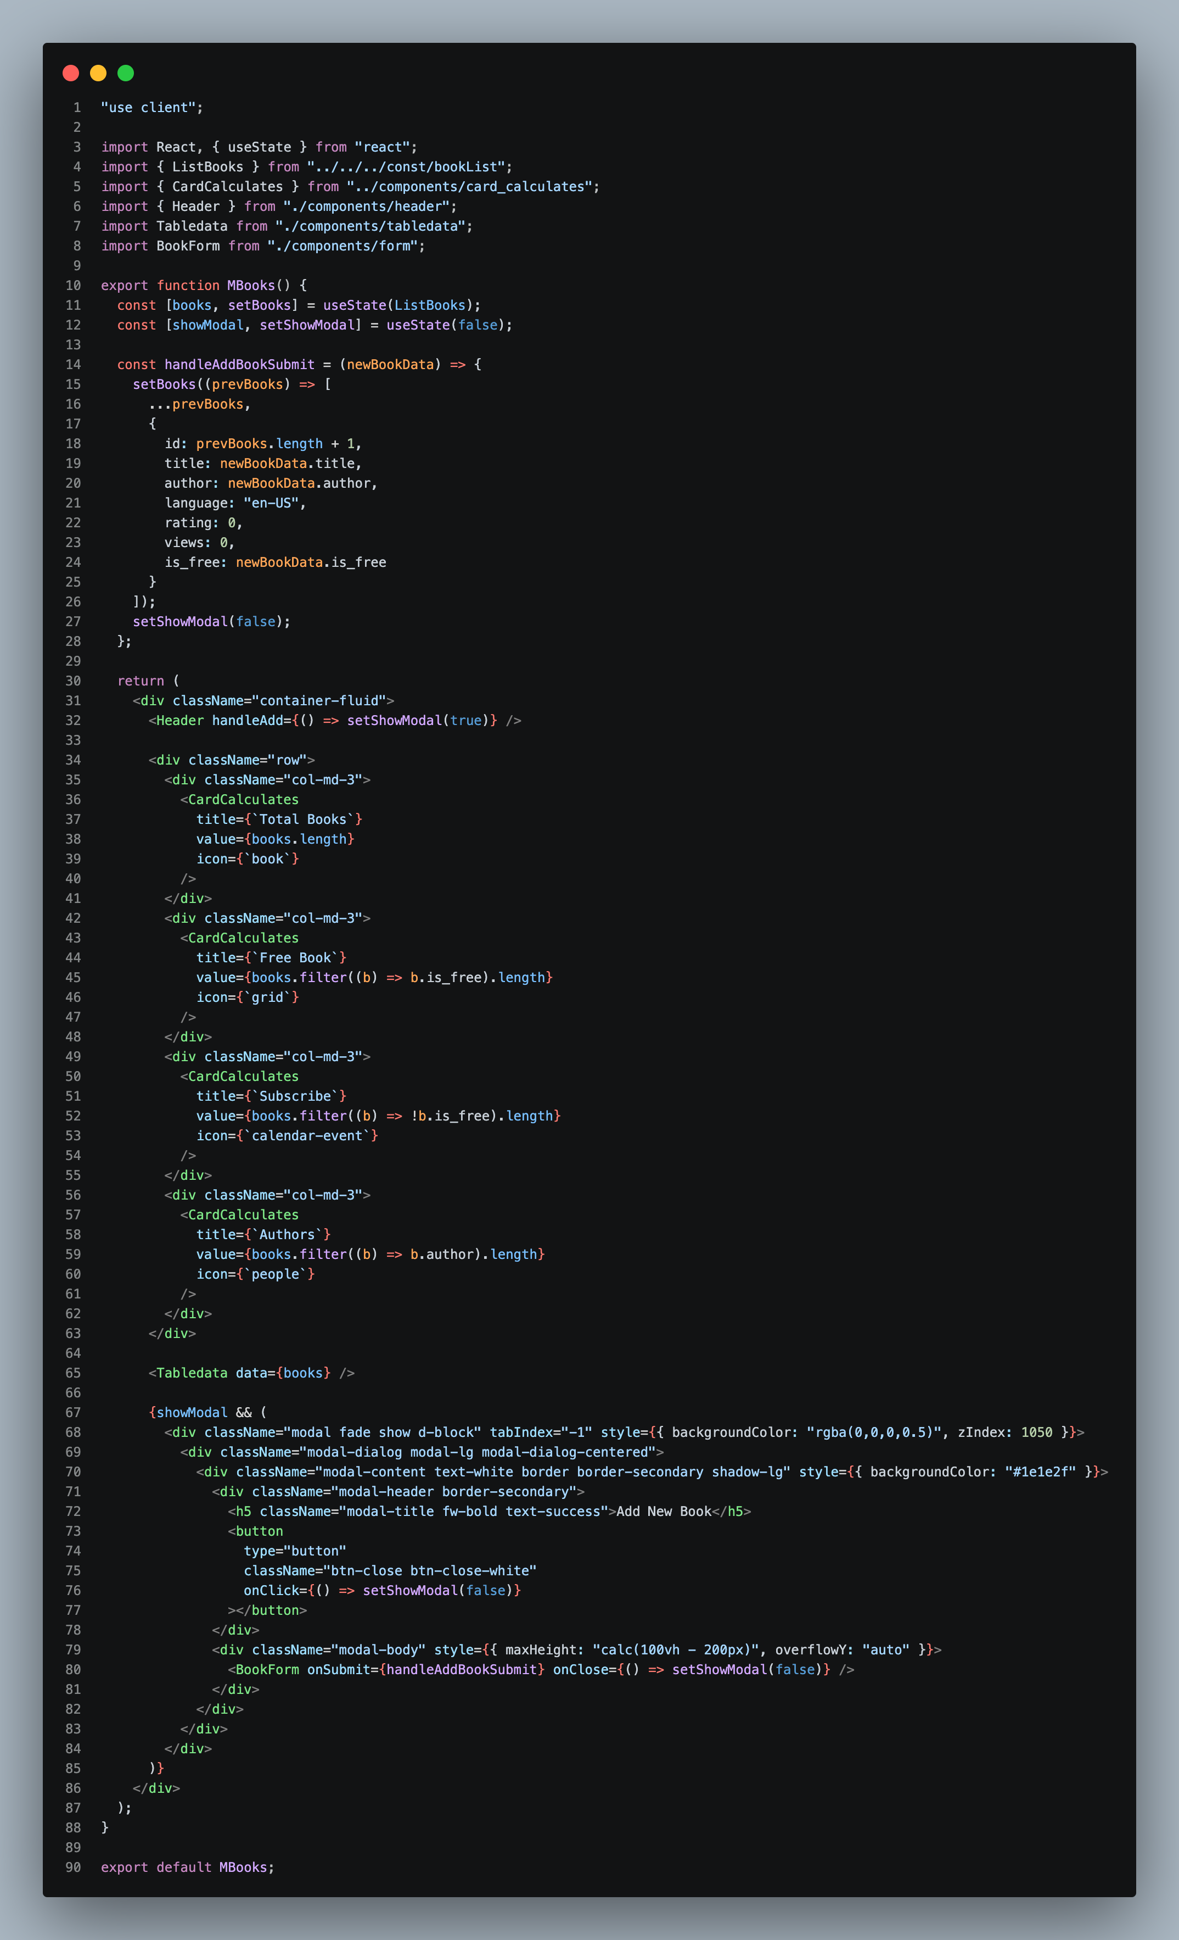

src/components/ui/form.jsx
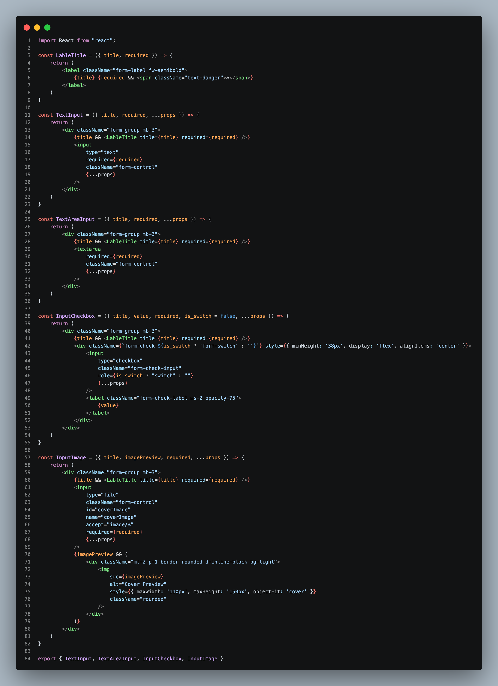

OUTPUT
